NET731 FA 3 WEEK6- Cloud Security Review
NHLANHLA J NKOSI
20232271

In this practical, I reviewed the security posture of an Azure-hosted environment using Microsoft Defender for Cloud. The goal was to identify security weaknesses, apply remediations, and improve the overall Secure Score of the environment.
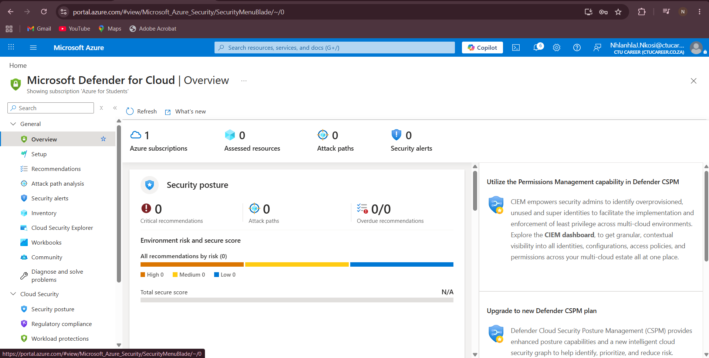

The Azure for Students subscription policy limited the chosen regions and resources, therefore the virtual machine deployment could not be finished. Despite testing several geographies and virtual machine sizes, subscription restrictions prevented deployment validation from succeeding.
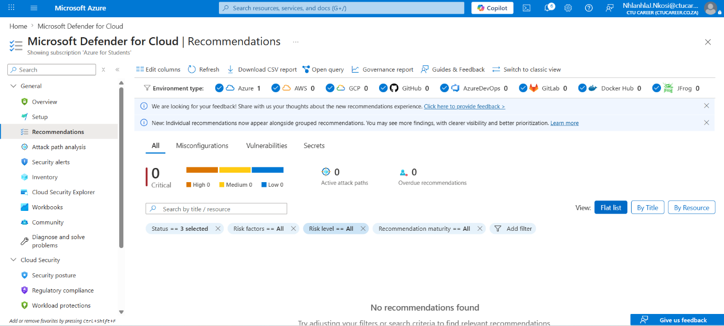
Task 2 remediation- closing open port
Step 1: I opened the Networking section of the Azure Virtual Machine.
Step 2: I reviewed the existing Network Security Group (NSG) inbound rules.
Step 3: I identified that management ports such as RDP (3389) or SSH (22) were open to all IP addresses.
Step 4: I edited the NSG rule and restricted access by either removing the rule or limiting access to trusted IP addresses only.
Step 5: After saving the changes, I confirmed that the environment was more secure and the recommendation was resolved in Defender for Cloud.

Task 3 remediation- enable OS ypdates
Step 1: I navigated to Azure Update Manager for the selected virtual machine.
Step 2: I reviewed the missing operating system updates and configured automatic patch management.
Step 3: I enabled update scheduling to ensure that future security patches would be installed automatically.
Step 4: I verified that the update configuration was successfully applied to the virtual machine.

